**DAILY ONLINE ACTIVITIES SUMMARY**

|  |  |  |  |  |  |  |  |  |
| --- | --- | --- | --- | --- | --- | --- | --- | --- |
| **Date:** | **30/07/2020** | | | | | **Name:** | **Sinchana K N** | |
| **Sem & Sec** | **4th SEM. & ‘B’ SEC.** | | | | | **USN:** | **4AL18CS083** | |
| **Online Test Summary** | | | | | | | | |
| **Subject** | | **Microcontroller and Embedded Systems** | | | | | | |
| **Max. Marks** | | **30** | | **Score** | | | **--** | |
| **Certification Course Summary** | | | | | | | | |
| **Course** | **Python data structure** | | | | | | | |
| **Certificate Provider** | | | **Coursera** | | **Duration** | | | **19 weeks** |
| **Coding Challenges** | | | | | | | | |
| **-----** | | | | | | | | |
| **Status : --** | | | | | | | | |
| **Uploaded the report in Github** | | | | | **Yes** | | | |
| **If yes Repository name** | | | | | **--** | | | |
| **Uploaded the report in slack** | | | | | **Yes** | | | |

**Online Test Summary: 18CS44 Descriptive IA test was scheduled from 09:30 AM to 10:15 AM.The portion for the IA was 2nd module, there were 6 Questions.**

**Online Certification course Summary:**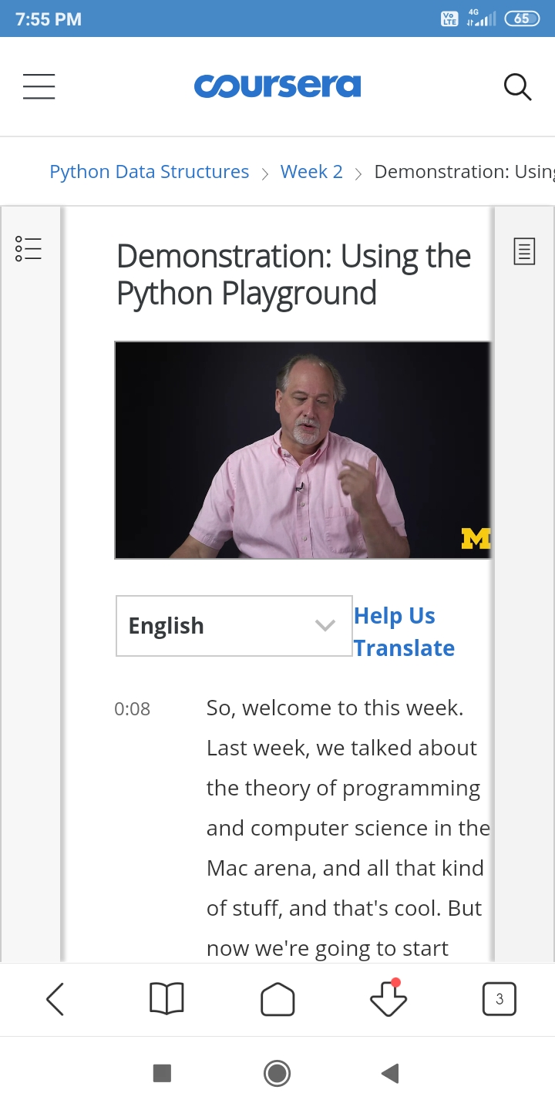Today I continued new course in Coursera, Python Data Structure which is of 19 Hrs course.

**Online Coding Summary: Today I didn’t receive the program.**

**Online Training Program: No session held today.**